CS 4407-01 Data Mining and Machine Learning

Instructor: Professor Shabia Shabir

Name: Anonymos

Programming Assignment Unit 5

**Part 1: Output of Decision Tree**

The decision tree for the given Ionosphere dataset is constructed and visualized using R. The steps are as follows:

**a. Setting the Working Directory and Loading Packages**

Set the working directory, load the required packages (`rpart` and `mlbench`), and then load the Ionosphere dataset.

```R

# Setting the working directory (modify as needed)

setwd("/Users/hayashir/work/Github/UoPeople/CS4407-branch/CS4407/unit5/PA")

# Loading packages

library(rpart)

library(mlbench)

# Loading the dataset

ionosphere_data <- read.table("Ionosphere.txt",

header = FALSE,

sep = ",",

stringsAsFactors = TRUE)

# Adding column names

colnames(ionosphere_data) <- c(paste0("V", 1:34), "Class")

# Verifying the dataset

head(ionosphere_data)

summary(ionosphere_data)

```

This step ensures that the Ionosphere.txt dataset is correctly loaded as a dataframe with 34 continuous columns and 1 class label column (`Class: "g" or "b"`).

**b. Creating the Decision Tree**

Use the `rpart()` function to create a decision tree for classification. This model predicts the `Class` (whether the signal is good or bad).

```R

# Creating the decision tree

ionosphere_tree <- rpart(Class ~ ., data = ionosphere_data)

# Displaying the summary of the decision tree

print(summary(ionosphere_tree))

```

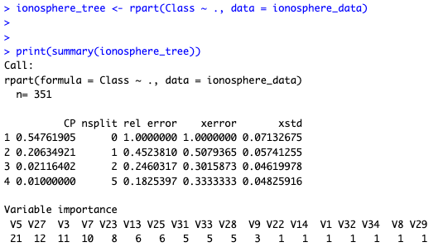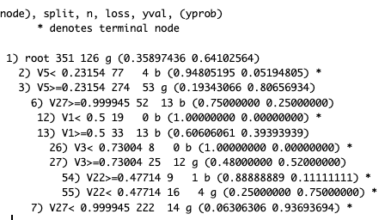

Figure 1: Overview of the Decision Tree

**c. Visualizing the Decision Tree**

Use the `plot()` and `text()` functions to visualize the constructed decision tree. The commands are as follows:

```R

# Adjusting margins

par(mar = c(4, 4, 4, 4))

# Plotting the decision tree

plot(ionosphere_tree, uniform = TRUE, main = "Ionosphere Decision Tree")

# Adding labels to nodes

text(ionosphere_tree, use.n = TRUE, all = TRUE, cex = 0.8)

```

The results are as follows:

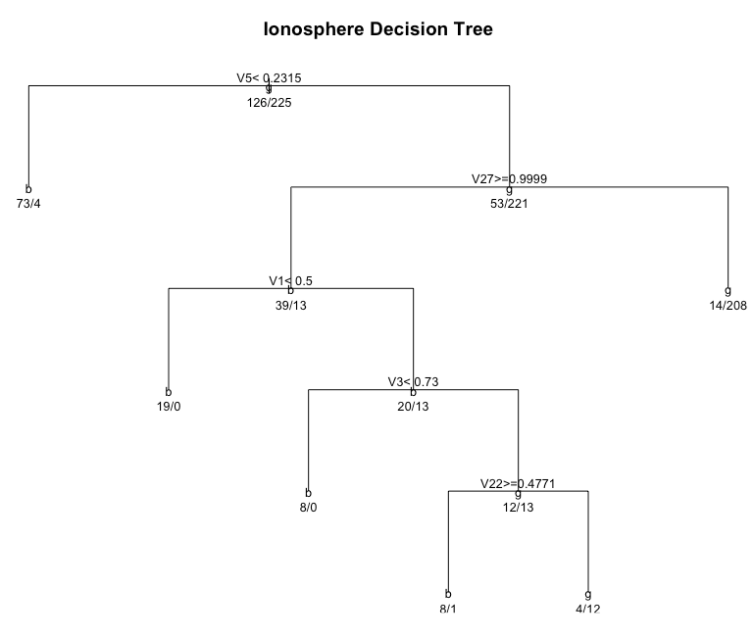

Figure 2 Ionosphere Decision Tree

**Part 2: Evaluating Accuracy**

This section involves splitting the Ionosphere dataset into training and testing datasets, building a decision tree, and evaluating its prediction accuracy on the test data.

**a. Splitting the Data**

Split the dataset into training (70%) and testing (30%) datasets using the `sample()` function.

```R

set.seed(123)

# Splitting the data into 7:3

train_indices <- sample(1:nrow(ionosphere_data), 0.7 * nrow(ionosphere_data))

train_data <- ionosphere_data[train_indices, ]

test_data <- ionosphere_data[-train_indices, ]

```

**b. Creating the Decision Tree with Training Data**

Build a new decision tree using the training data.

```R

# Creating the decision tree with training data

ionosphere_tree_train <- rpart(Class ~ ., data = train_data)

# Displaying the summary of the model

print(summary(ionosphere_tree_train))

```

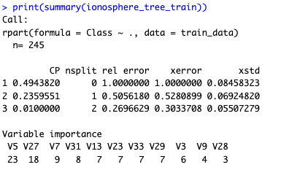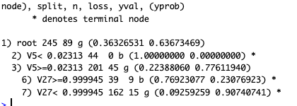

Figure 3: Decision Tree Overview for Test Data

**c. Predicting with the Test Data**

Use the `predict()` function to make predictions based on the test data.

```R

# Making predictions with the test data

test_predictions <- predict(ionosphere_tree_train, newdata = test_data, type = "class")

```

**d. Calculating Accuracy**

Compare the predicted results with the actual class labels in the test data and calculate the model's accuracy.

```R

# Creating a confusion matrix

confusion_matrix <- table(test_predictions, test_data$Class)

# Calculating accuracy

accuracy <- sum(diag(confusion_matrix)) / sum(confusion_matrix)

# Displaying the results

print(confusion_matrix)

print(paste("Accuracy: ", round(accuracy * 100, 2), "%"))

```

The measured accuracy is as follows:

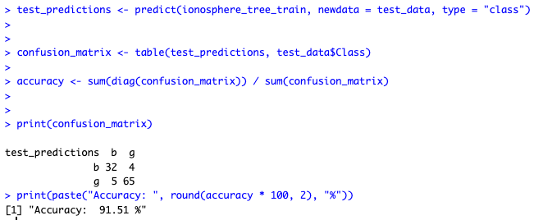

Figure 4: Accuracy Calculation of the Model

Word Count: 476

References

1. James, G., Witten, D., Hastie, T., & Tibshirani, R. (2013). *An Introduction to Statistical Learning with Applications in R*. New York, NY: Springer.